[Document title]

[Company name] | [Company address]

[Document subtitle]

Marvin Coronel

2023

**School of Information Technology**

**New Zealand Diploma in Software Development (Level 6)**

**Cover Sheet and Student Declaration**

This sheet must be signed by the student and attached to the submitted assessment.

|  |  |  |  |
| --- | --- | --- | --- |
| **Course Title:** | SWD607 Mobile and App Development | **Course code:** | **SWD607** |
| **Student Name:** | **Marvin Coronel** | **Student ID:** | **764700878** |
| **Assessment No & Type:** | **Assessment 1**  ProjectProposal | **Cohort:** | **NZDSD6221C** |
| **Due Date:** |  | **Date**  **Submitted:** |  |
| **Tutor’s Name:** |  |  |  |
| **Assessment**  **Weighting** | 30% |  |  |
| **Total Marks** | 100 |  |  |

**Student Declaration:**

I declare that:

* I have read the New Zealand School of Education Ltd policies and regulations on assessments and understand what plagiarism is.
* I am aware of the penalties for cheating and plagiarism as laid down by the New Zealand School of Education Ltd.
* This is an original assessment and is entirely my own work.
* Where I have quoted or made use of the ideas of other writers, I have acknowledged the source.
* This assessment has been prepared exclusively for this course and has not been or will not be submitted as assessed work in any other course.
* It has been explained to me that this assessment may be used by NZSE Ltd, for internal and/or external moderation.
* If I am late in handing in this assessment without prior approval (see student regulations in handbook), marks will be deducted, to a maximum of 50%.

**Student signature:**

**Date:**

|  |  |  |
| --- | --- | --- |
| **Tutor only to complete** |  |  |
| **Assessment result:** | **Mark /100** | **Grade** |

Table of Contents

**Introduction3**

**Project Planning4**

Project Goals and Objectives4

Project Scope Statement5-6

Project Development Methodology7

Project Technology Stack8-9

**Requirement Analysis10**

Use Case Diagram10

Activity Diagram11-18

**Design19**

Wireframes19-27

User Interface (UI) Mock-ups28-39

Mock-ups and Evaluation40-47

**Reflection48**

**References49**

### INTRODUCTION

Valcorton, an Auckland based start-up tech company, intends to develop a mobile application for their business. The primary goal is to create a user-friendly and engaging platform that allows food enthusiasts to discover, save, and share their favourite recipes with others.

With this app, users will have access to a vast collection of recipes from around the world, ranging from appetizers and main courses to desserts and drinks. The app will offer a variety of search filters to make it easy for users to find recipes based on their preferences, such as cuisine type, dietary restrictions, cooking time, and more.

In addition to browsing recipes, users will be able to save their favourite recipes to their own personalized recipe book and share them with friends and family and get recommendation and suggestions for the trending recipes.

Our team is dedicated to creating an app that not only satisfies users' hunger for delicious meals but also provides a fun and interactive platform to inspire and connect people through the joy of cooking.

This report is a compilation of screenshots for the low fidelity wireframe and UI design of the mobile application, the use case diagram to summarize information about the system and its users, the activity diagram to define the system's various dynamic aspects, and the initial project planning. The project involves three team members that had participated and contributed to completion of the documentation and enabled to deliver a project report according to the sponsors needs and goals.

### PROJECT PLANNING

#### Project Goal and Objectives

**Technical Objectives:**

Design and develop a user-friendly interface for the recipe application. Build a database to store user-submitted recipes and user profiles. Implement search and filter functionality to help users find recipes based on various criteria. Incorporate social media sharing and community features to encourage user engagement and contribution.

Develop and implement a recipe submission and review process to ensure high-quality content.

**Schedule Objectives:**

Complete wireframes and UI mock-ups within 2 weeks.

Develop and test application features in sprints over a period of 2 month.

Conduct user testing and refine the application over the course of 2 weeks.

Launch the application within 3 months of the project start date.

**Cost Objectives:**

Develop the application within a budget of $30,000.

Use open-source technologies and tools where possible to reduce costs.

Hire a small team of developers to complete the project within the given budget.

**Special Objectives:**

Create an inclusive and welcoming community for users of all skill levels and backgrounds.

Build a diverse and extensive recipe library that represents a wide range of cultural cuisines.

Encourage healthy and sustainable cooking practices through the promotion of plant-based, low-waste, and locally sourced recipes.

Overall, the goals of the Recipal project are to create an interactive and engaging recipe-sharing platform that provides users with a diverse range of high-quality recipes from around the world, while also encouraging healthy and sustainable cooking practices. The project's objectives aim to achieve these goals through the development of user-friendly and technically sound software, managed within a defined timeline and budget.

Project Scope Statement

|  |  |  |  |
| --- | --- | --- | --- |
| Project Name: | Food Recipe Mobile Application for Valcorton | | |
| Company: | Valcorton | Team Member: | Marvin Coronel |
| Team Member: | Darren Burton | Team Member: | Rocelle Valdez |

|  |  |
| --- | --- |
| Stakeholders | The following are the project stakeholders for the Mobile Application project:   * Project Manager * Team members * Company owners * Investors * Sponsors * End users |
| Project Description | This project will design and make a Food Recipe Mobile Application that is available through app stores and can be download for free. The application allows users to create a new account, sign-in to the app, update his/her profile, share their own recipes, find food recipe, saved or favourite recipe, and get recommendation and suggestions for the trending recipes. Users can also view the food’s ingredients, nutritional value, and dietary preferences. |
| Acceptance Criteria | The project can only be considered complete when:   * The successful design of the Food Recipe Mobile Application. * Launching the Food Recipe Mobile Application to the appropriate app store, Google Play for Android apps. * The mobile application meeting the timeframe allotted and aligning the project goals and objectives while having none to less bugs and errors during deployment phase. |
| Project Deliverables | The project will create the following based on the client’s requirements:   * Initial Design including;   + - * Wireframes       * Mock-ups * Time-tracking report * Project budget report * Progress report * Final design * Final product |
| Project Exclusions | The following are the factors that are out of the project scope:   * The project will create a Mobile Application but will not provide any equipment or machine to the company. * Email hosting services |
| Project Constraints | The following are the restriction’s the project will have:   * The project must be able to deliver an acceptable state by 28th of April 2023. * The project should be completed within the allocated budget. * The product should meet the needs and requirements of the client. * The application is only limited for android users that has android version 6 and above. * The prototype should be accepted by the sponsor to continue the project. * Valcorton has only three team members who are working on the project planning, design, and development and deployment. * Project has a total of three sprint review meetings and the Project Sponsor joins for the meeting every sprint review. |
| Project Assumptions | Here are the few assumptions for the project management:   * The sponsor will continue its support throughout the project cycle. * The team members will be available for the project. * The project will be completed within the allotted time. * During deployment the software is expected to run with less to none bugs or errors and will execute accordingly. |

Project Development Methodology

Agile is an approach that enables a team to conduct a project more productively by dividing it up into phases, all of which enables for constant engagement with stakeholders to enhance steady improvements on every phase.

© https://www.pm-partners.com.au/the-agile-journey-a-scrum-overview/

The motivation behind selecting these technologies is that the Agile-Scrum methodology motivates faster product development because every goal set should be accomplished within the specified timeframe of every sprint. It also prompts regular scheduling and goal setting, that assists the scrum team in focusing on the sprint's priorities and increasing productivity and if issues or adjustments arise, the group could quickly modify product goals throughout the following sprints to deliver more useful iterations. Stakeholders are more satisfied as they receive precisely what they demand after becoming engaged throughout every phase of the process.

Project Technology Stack

For the project, the following technologies have been selected:

**Programming Language**:

*JavaScript* - JavaScript is a high-level, dynamic, and interpreted programming language that is widely used for front-end development. It is a popular choice for web development due to its versatility, ease of use, and support for a variety of frameworks and libraries.

*Python* - Python is a high-level, interpreted programming language that is widely used for a variety of applications, including back-end development, data analysis, machine learning, and more. It is a popular choice due to its simplicity, readability, and large community of users.

**Platform**:

*React Native* - React Native is a platform that allows developers to build native mobile applications using JavaScript and React. It is a popular choice for building cross-platform mobile applications because it provides a consistent user experience across different platforms and allows for easy code sharing between iOS and Android.

**Framework**:

*Django* - Django is a high-level Python web framework that allows developers to quickly build web applications with minimal overhead. It provides a built-in administrative interface, an Object-Relational Mapping (ORM) system for database management, and a robust security framework, making it an ideal choice for back-end development.

**Database Management System**:

*SQL* - SQL (built-in with Django) Django comes with a built-in SQL database management system that provides a simple and efficient way to store and manage data. The built-in SQL database management system eliminates the need for a separate database management system, making it a convenient choice for developers.

**Integrated Development Environment (IDE):**

*Visual Studio Code* - Visual Studio Code is a popular, free, and open-source code editor that supports a wide range of programming languages and has a large community of users. It provides a robust set of features, including code highlighting, code completion, and integrated debugging, making it a convenient choice for developers.

The motivation behind selecting these technologies is that they are widely used, well-supported, and provide a robust set of features that make it easier to develop and maintain the project. Additionally, these technologies are well-suited for the project requirements, providing the necessary functionality, scalability, and ease of use for front-end and back-end development, database management, and code editing.

### REQUIREMENT ANALYSIS

Use case Diagram

Activity Diagram

### DESIGN

Wireframes

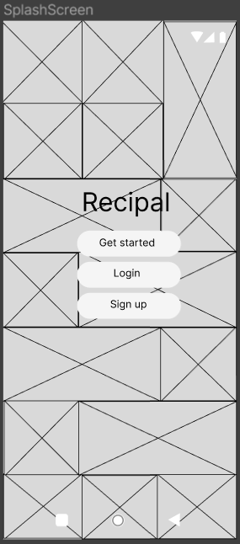

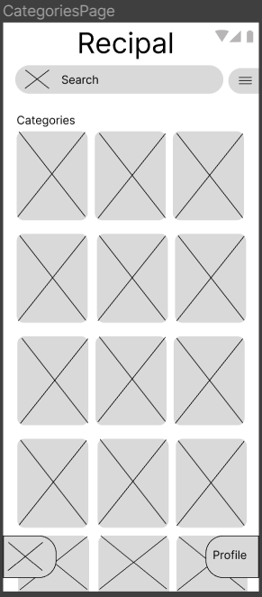

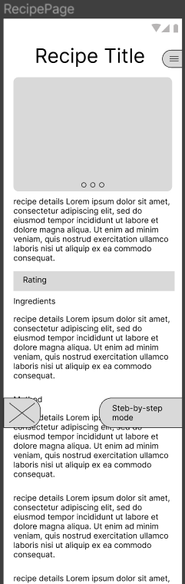

User Interface (UI) Mock-ups

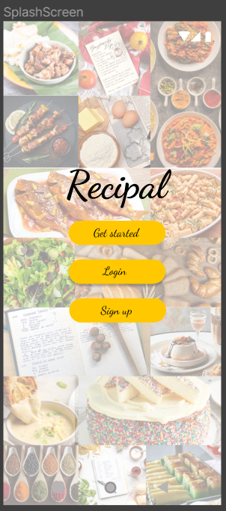

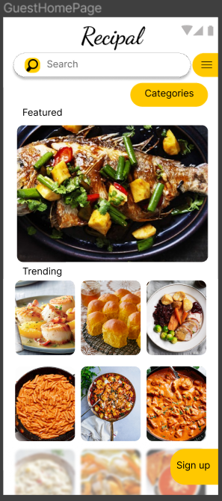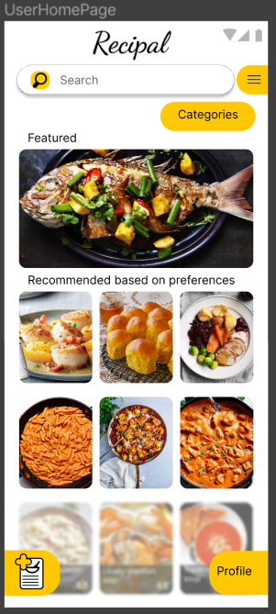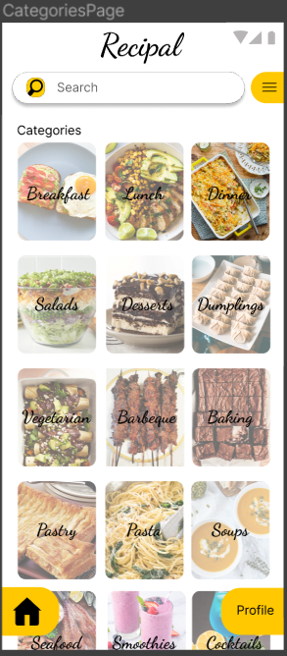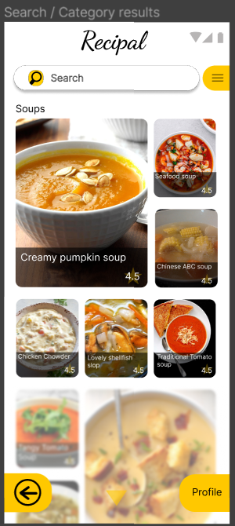 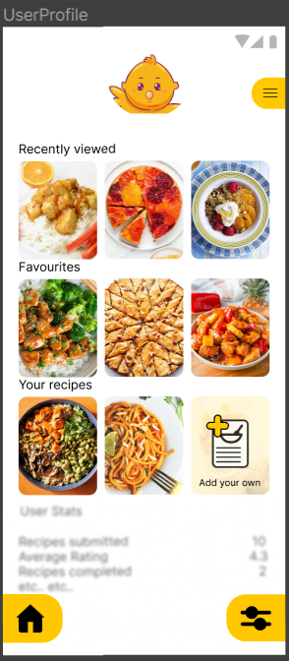 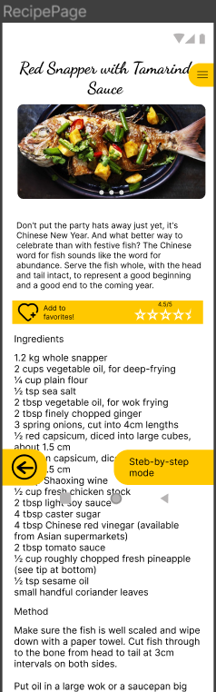

Mock-ups Evaluation

### REFLECTION

### REFERENCES

Agile-Scrum Methodology (2023). https://www.businessnewsdaily.com/4987-what-is-agile-scrum-methodology.html

Draw.io (2023). https://www.diagrams.net/blog/move-diagrams-net

Figma design. (2023). https://www.figma.com/ui-design-tool/